The Einstein Ring and Gravitational Lensing
Our group initially determined that there would be 3 prongs to our project. First we recreated Einstein’s 1919 light deflection experiment, modelled through computational methods. We modelled light rays being deflected by a large star such as the sun, which deflection occurs due to gravitational lensing.
The first prong
Each of us researched and learned how to utilise rk4 numerical methods in Python, and created our own scripts each to model this light deflection experiment with Python. It was discovered, that when the star had the same mass and radius as our Sun, the angle of deflection was given as 1.75 arcseconds. This value of 1.75 arcseconds matches Einstein’s 1.75 arcsecond result of 1919.

The way this works is by modelling a solar eclipse – by placing a moon in front of the Sun, and noticing that the star can still be seen by an observer, despite the moon blocking the view of the star. This means that the light being emitted from the star is being bent around the moon, creating the illusion that the star is in a different position to the position it truly is in. If you trace each ray coming from the star, you will find a ring of light around the moon – this is called the Einstein ring. We will find the angle of deflection of the rays of light, and compare our model to einstein’s experiment.

All members of the group used the rk4 methods to produce the same model. It worked, and everyone achieved a value of 1.75 arcseconds, which means the computational model for gravitational lensing, is, in fact, reliable for finding the same result as Einstein.

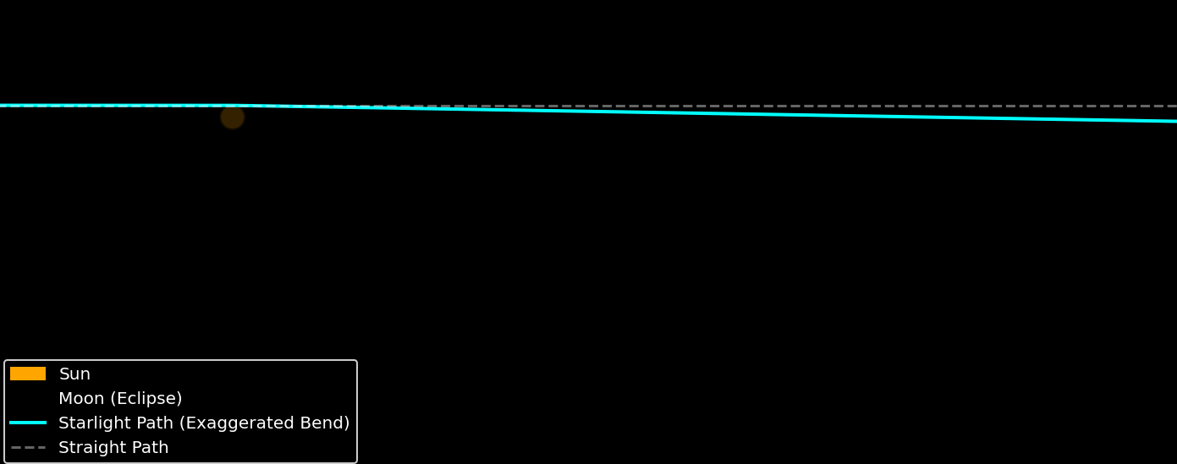
The second prong
Next is the Einstein Ring. Objects with mass cause gravitational lensing, which bends light around the mass, hence it being called a lens. All of the rays surrounding the mass generate an Einstein ring with a certain radius, surrounding the mass object. The mass of the object dictates how much gravitational lensing occurs, and thus the radius of the Einstein ring.
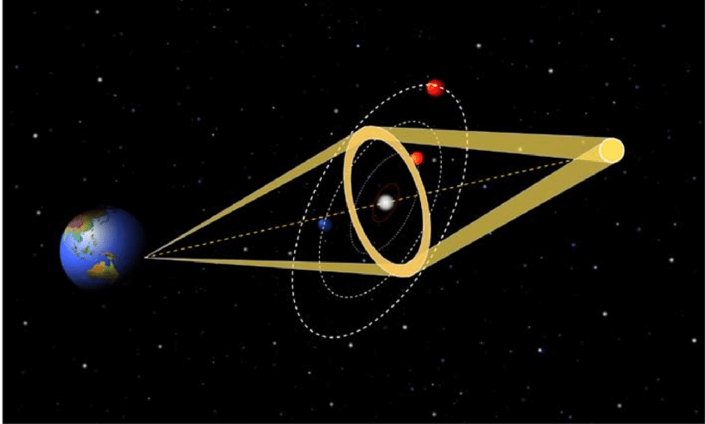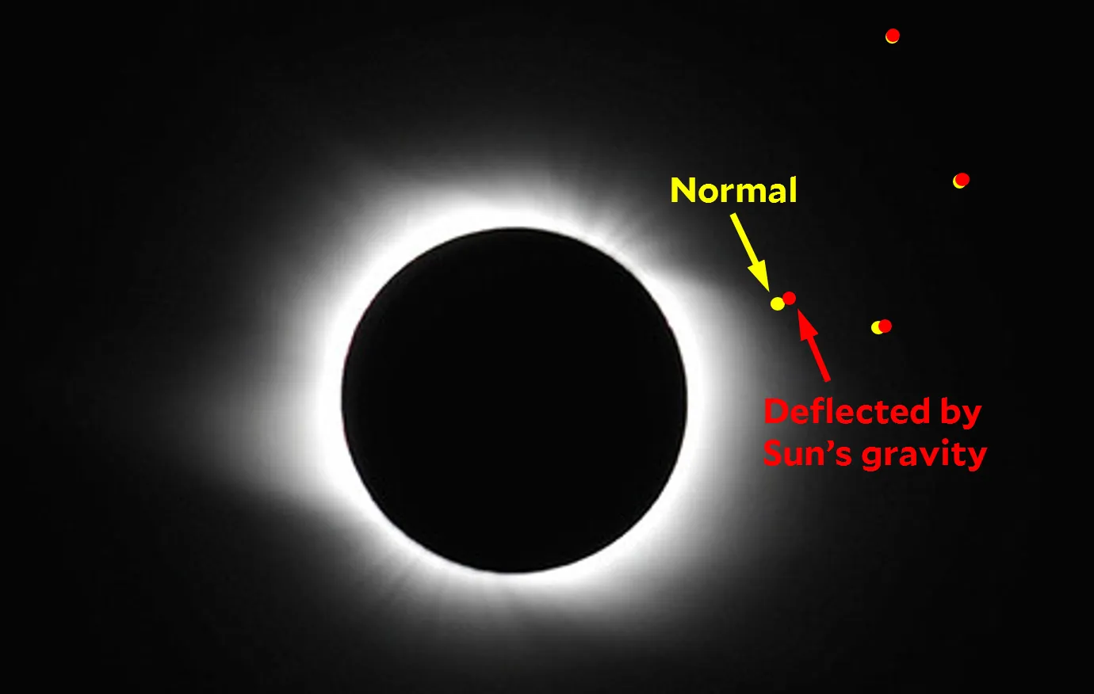
We modelled our own Einstein ring using the same geodesic equation as in the first prong to computationally model a gravitational lens. We adjusted the mass of the lens, and we saw what the Einstein ring angular radius, measured in radians, was. The distance between the lens and observer and the distance between the lens and the source are both important parameters to keep note of. If we take many measurements of the Einstein ring angular radius, for each corresponding lens mass, we can then choose any Einstein ring radius, and find the mass of the lens for which that ring is produced. We can then compare this experimental, computationally modelled mass value to the observed value from a large data set. If it is close, then the experiment is reliable.
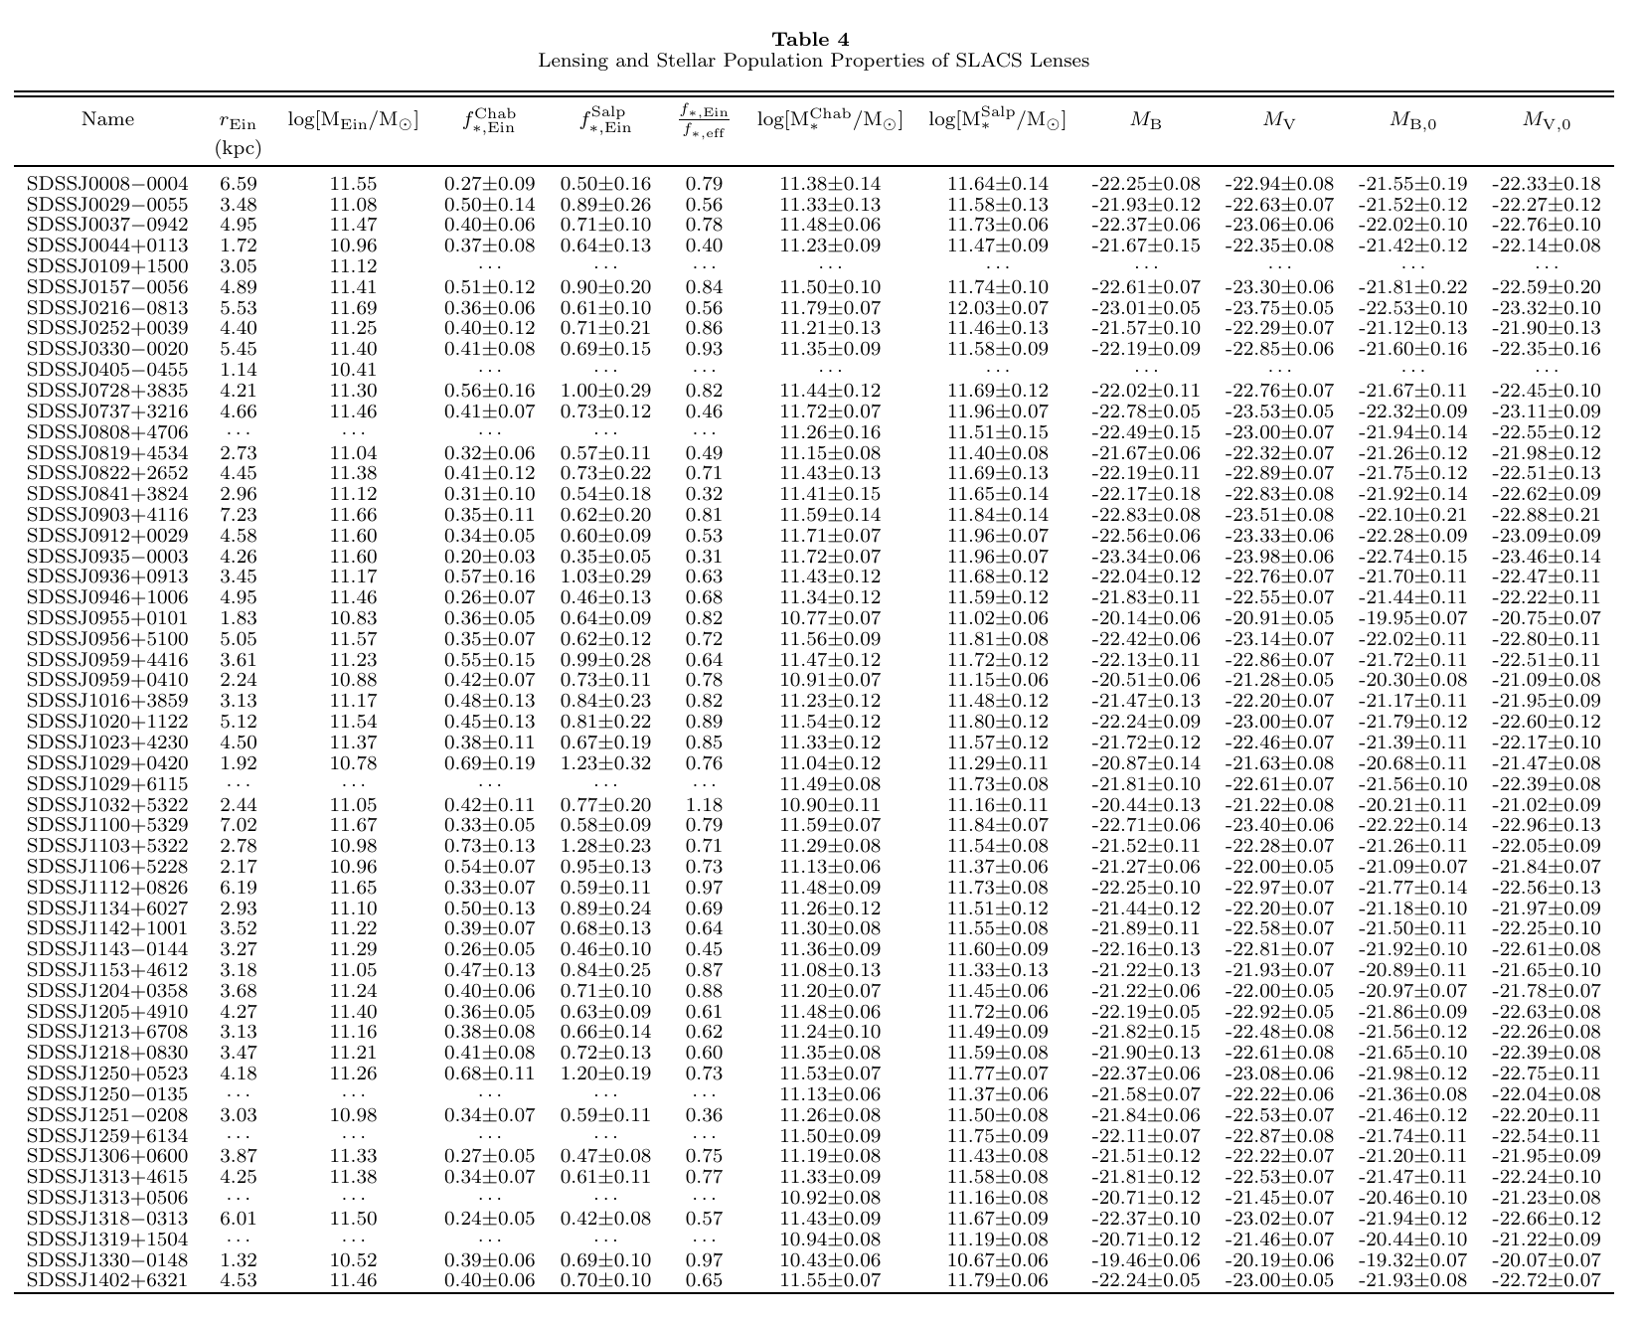
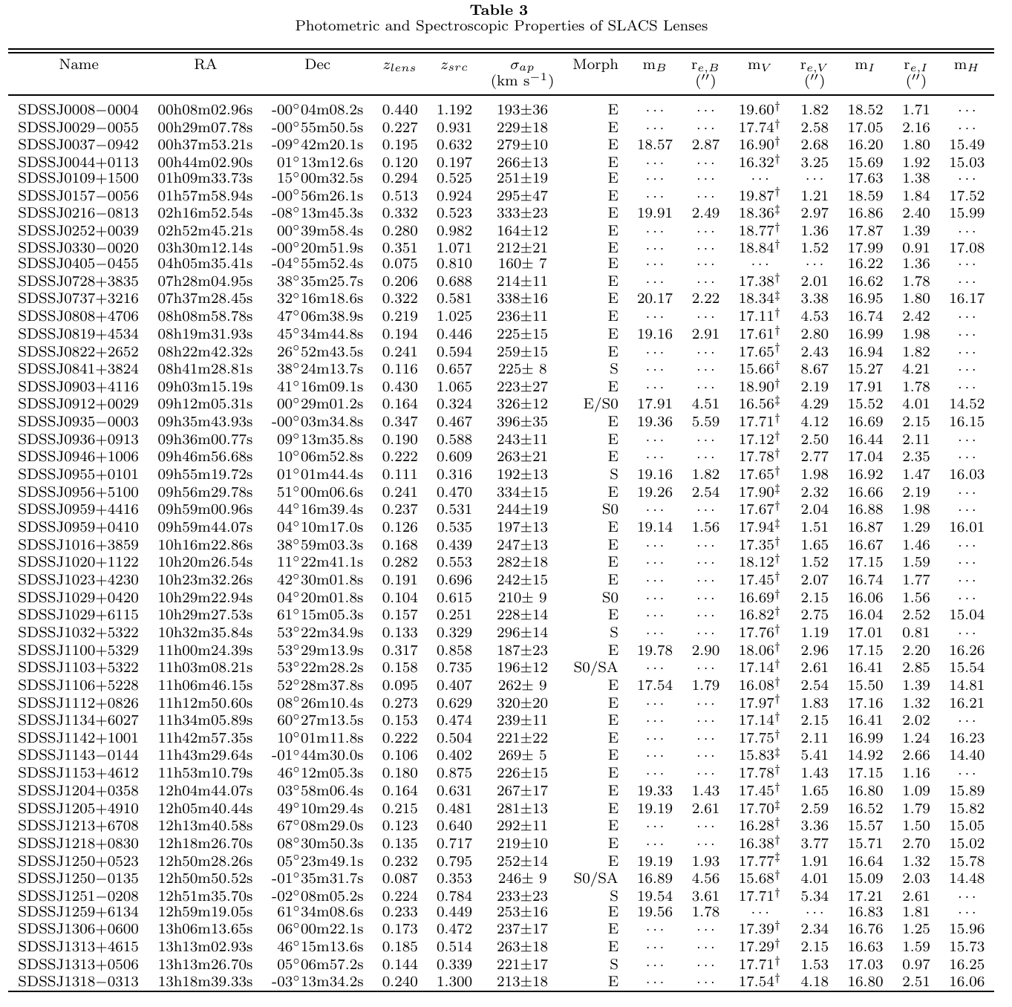
We took this data in Table 3 from a paper [1], and the data from table 4, and combined the columns of data we needed into a csv file. We also created 3 new columns, DL, DS, DLS, using Planck 18 parameters, and the redshifts zlens and zsrc, and a few equations, to find these distances. We combined this into one large csv dataset file, which we then uploaded into python, and used commands to clean the data. What remained was a cleaned dataset csv file.
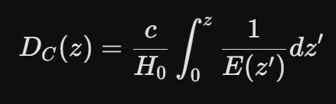
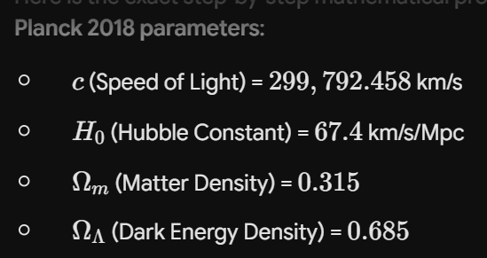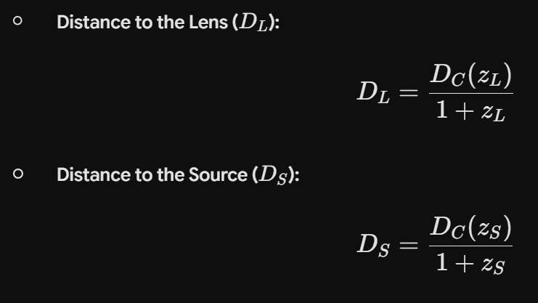
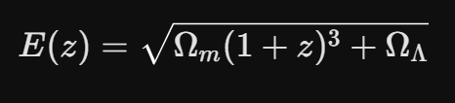

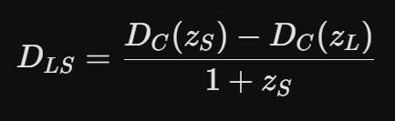
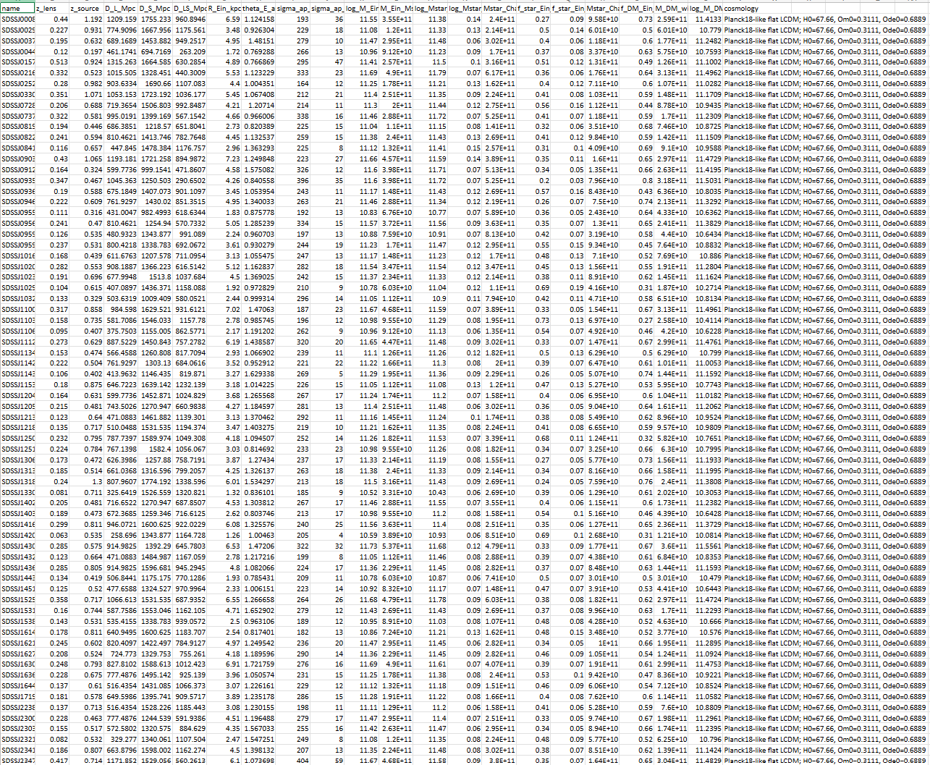
The third prong
This cleaned data was then compared to our geodesic model for gravitational lensing in the second prong. When using this model of the various distances DL, DS, and DLS, the model was found to be statistically unreliable – not close to the true data.
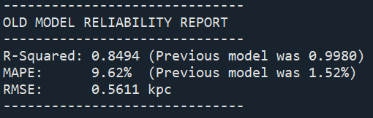
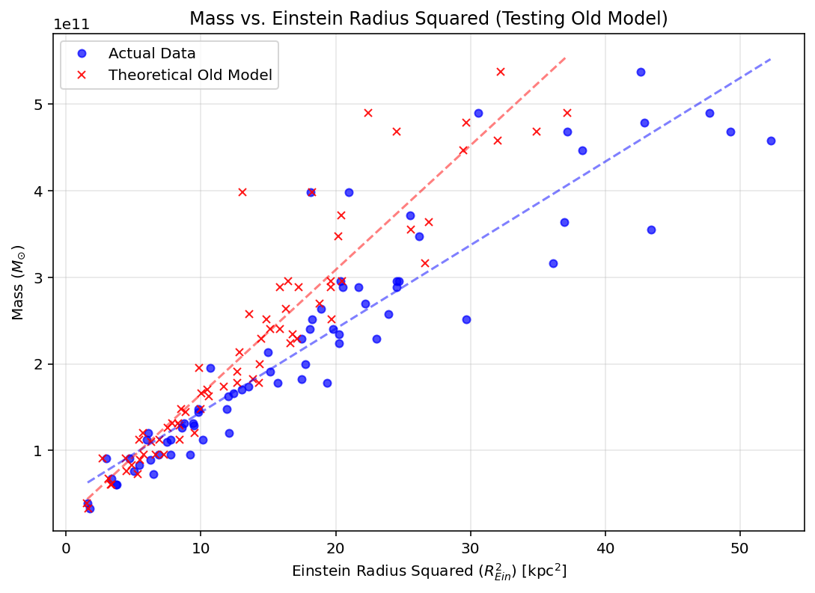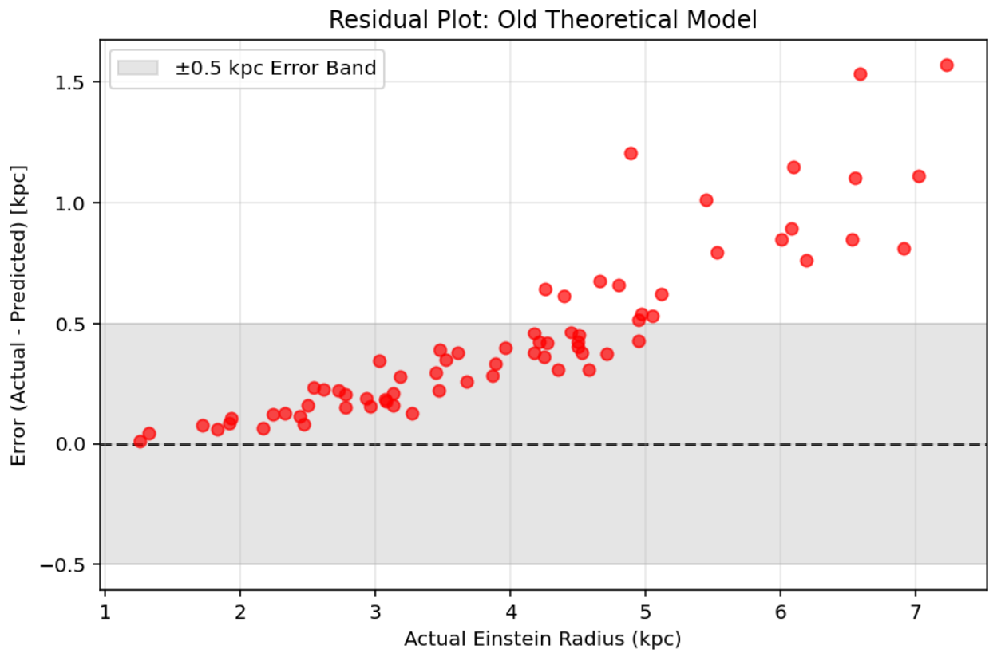

When we discovered there was a clear systematic error in the model, we remodelled, an instead used simply DLS, and used a formula to plot the new theoretical model:
CYRUS’ FORMULA -------------------
When we compared this model to the data, it was far more reliable, in fact, it was statistically reliable as a model for gravitational lensing, as it was very close to the true observed data. In this model, we used binary search methods to find the impact parameter for each lens, which meant the run time of the program was far quicker, as we weren’t ray tracing for many different angles, but far fewer:
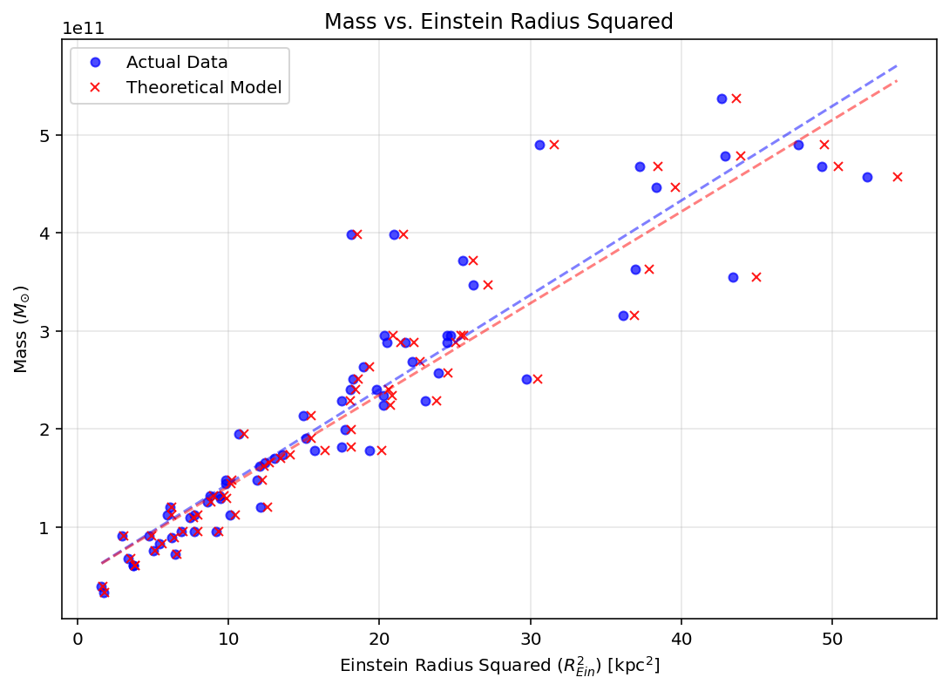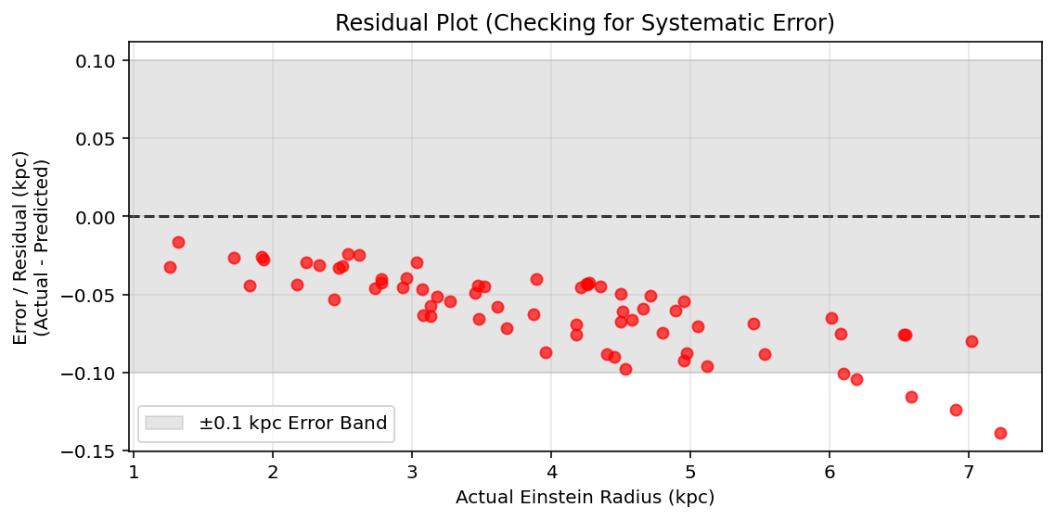
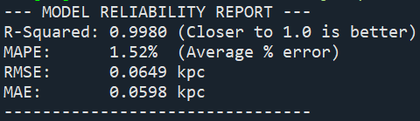
As can be seen, however, there is still a systematic error, but a much smaller one. This is likely due to the binary search method, which, for larger radii, the model appears to overshoots the radius.

Creating an image of the black hole will be particularly appealing to school leavers, as it is an exciting prospect of the unknown, which is what will get their attention.
When we began the project, these were the prongs we determined. However, having discussed with each other, and our supervisor, and given the time frame with which we have to finish the project, we determined that our main focus would be to first model Einstein’s ring, and retrieve as much data as possible, and that if we still had time, we would move onto the other 2 prongs (Dark Matter and Black Holes) of the project. To speed up the process, Leiyi stopped creating the 3D model, and instead began to work on the 2D model, as learning the skillset for the 3D model was an incredibly long and highly demanding task.,
In order to visualise this project, and make it more understandable, especially to school leavers, Leiyi used blender to create a visual representation of a gravitational lens.------ this may have changed

Prabhmeet and LEIYI’S STUFF:

- Prabhmeet’s goal: TO recreate Einstein’s 1.75 arcsecond angle of deflection for impact parameter = radius of the sun using RK4 in python.
- [[ PLACEHOLDER RK4 IMAGE BELOW, may be updated later ]]
- 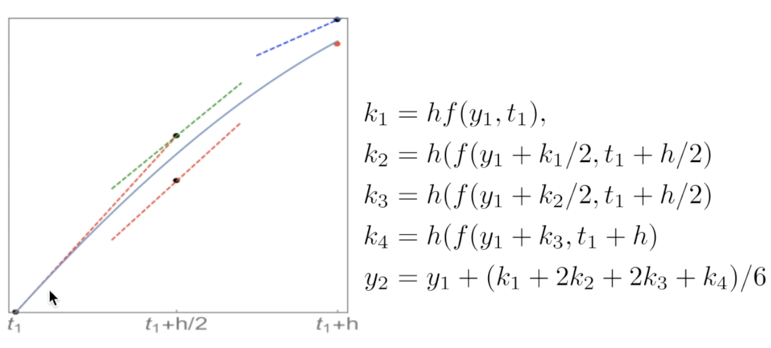
- Equation we need to use:
- Notice this is second order, so in order to predict D^2 U / d_phi ^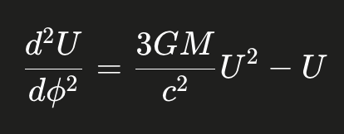2 WE NEED U and the first derivative of U
- BASICALLY if we know U and the first derivative of U we can predict D^2 U / d_phi ^2 and therefore we can predict how U varies with Phi
- LOOK AT THE FUNCTION: we need delta_phi, phi_0, U_0, and V_0
- 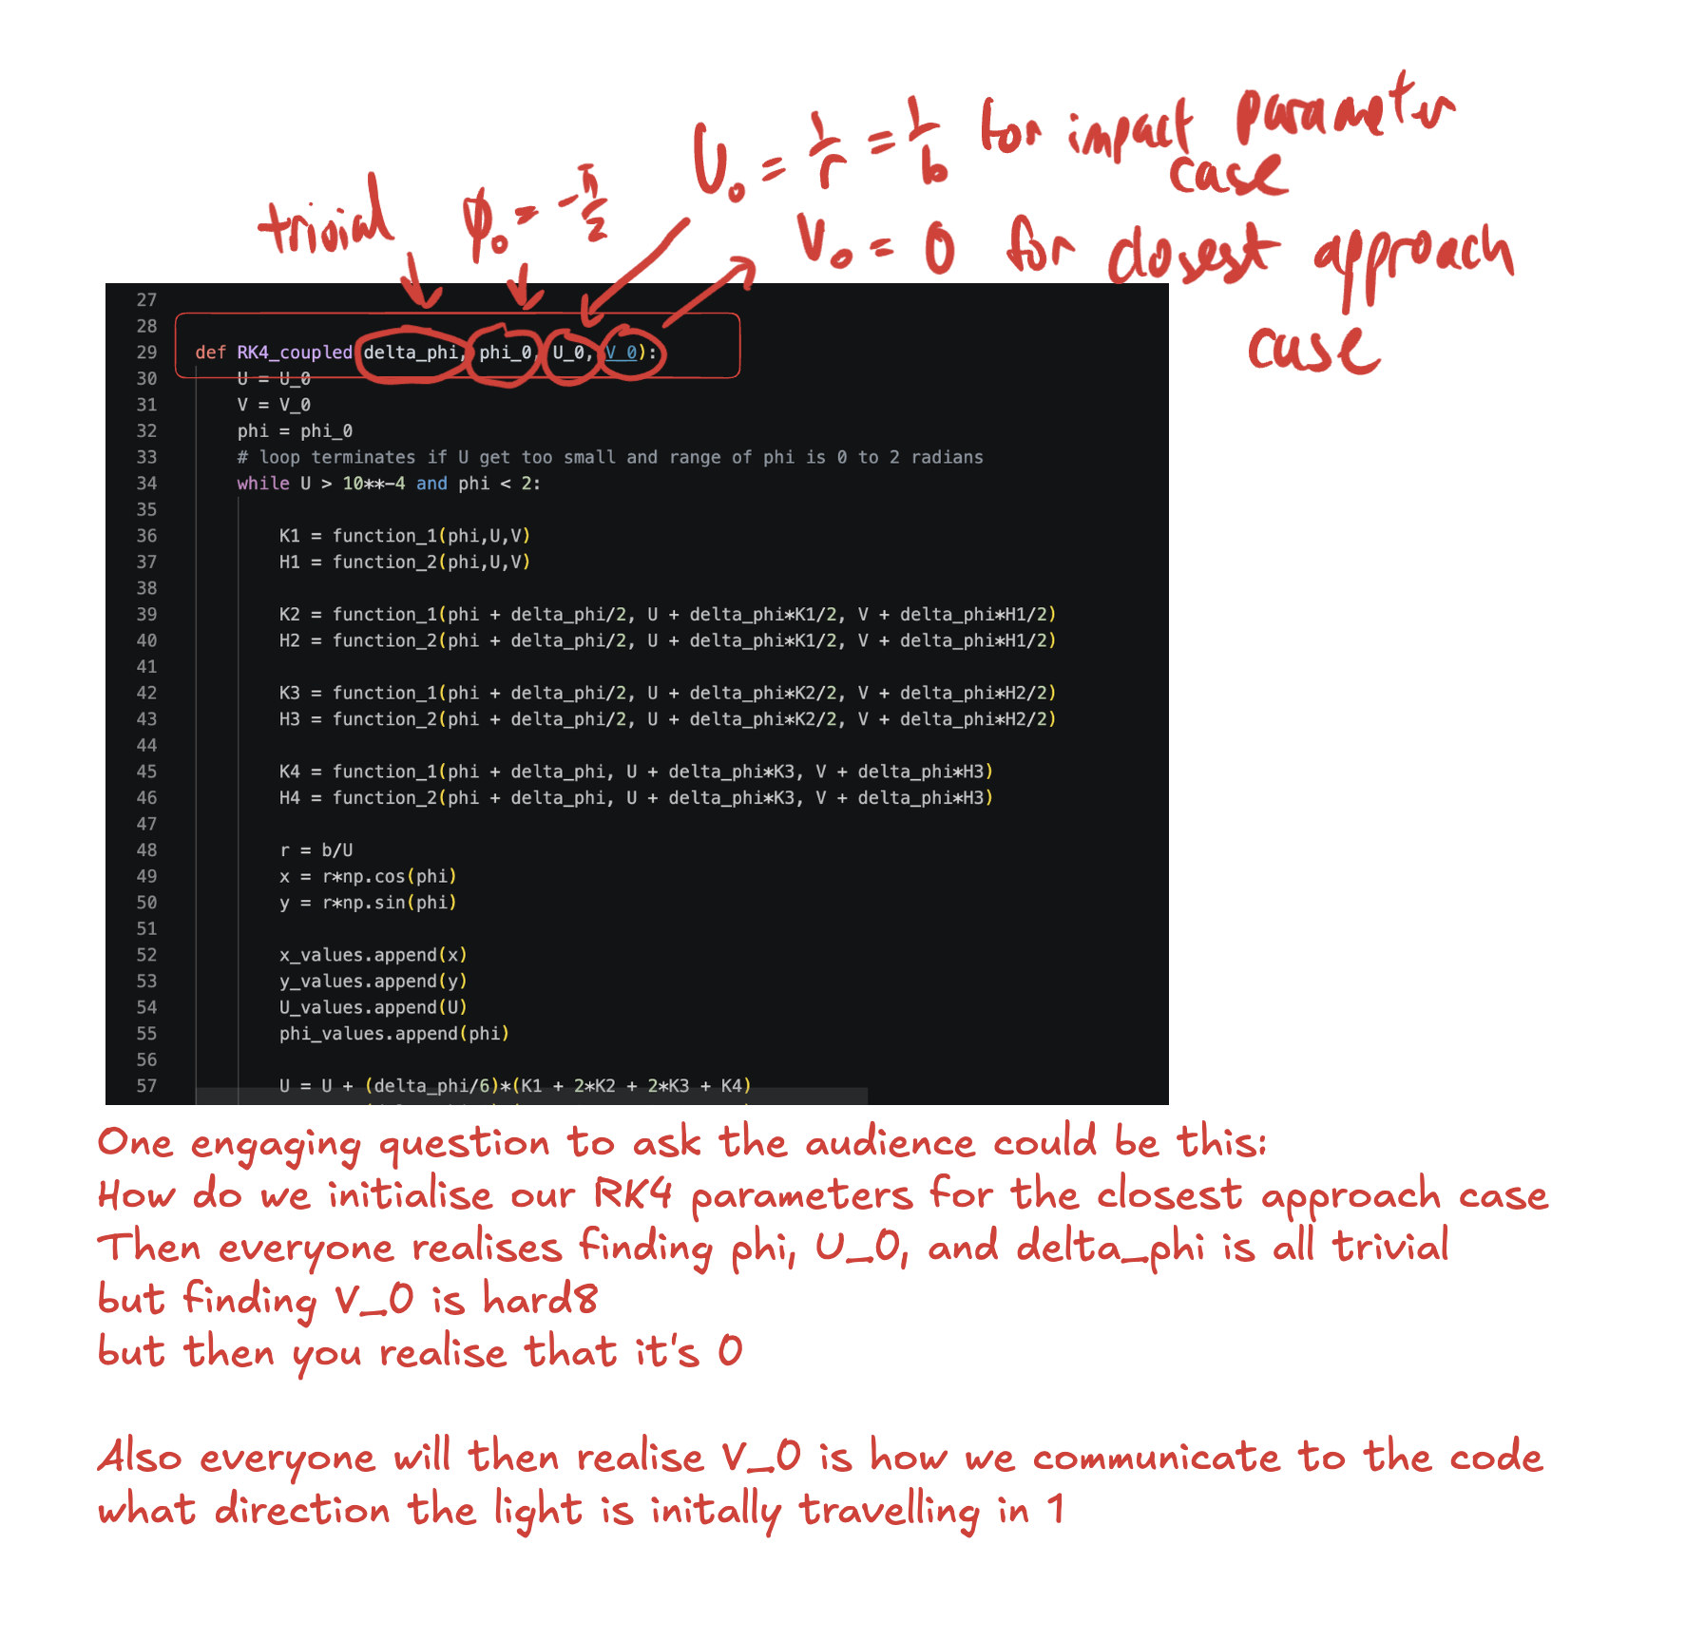
- 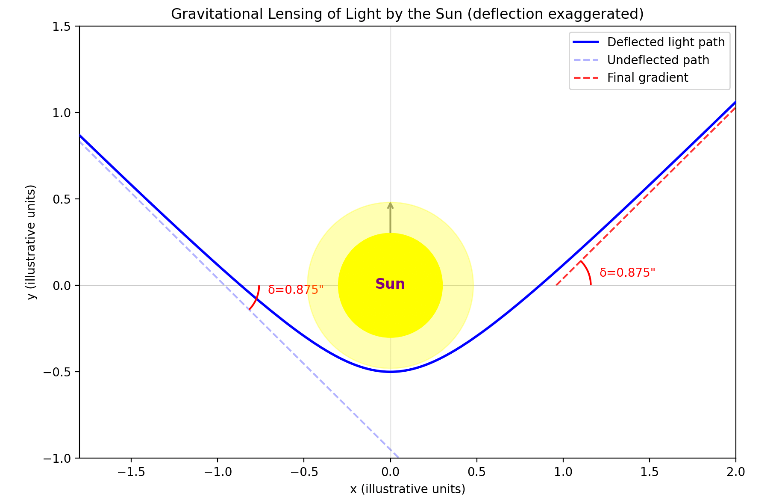
- 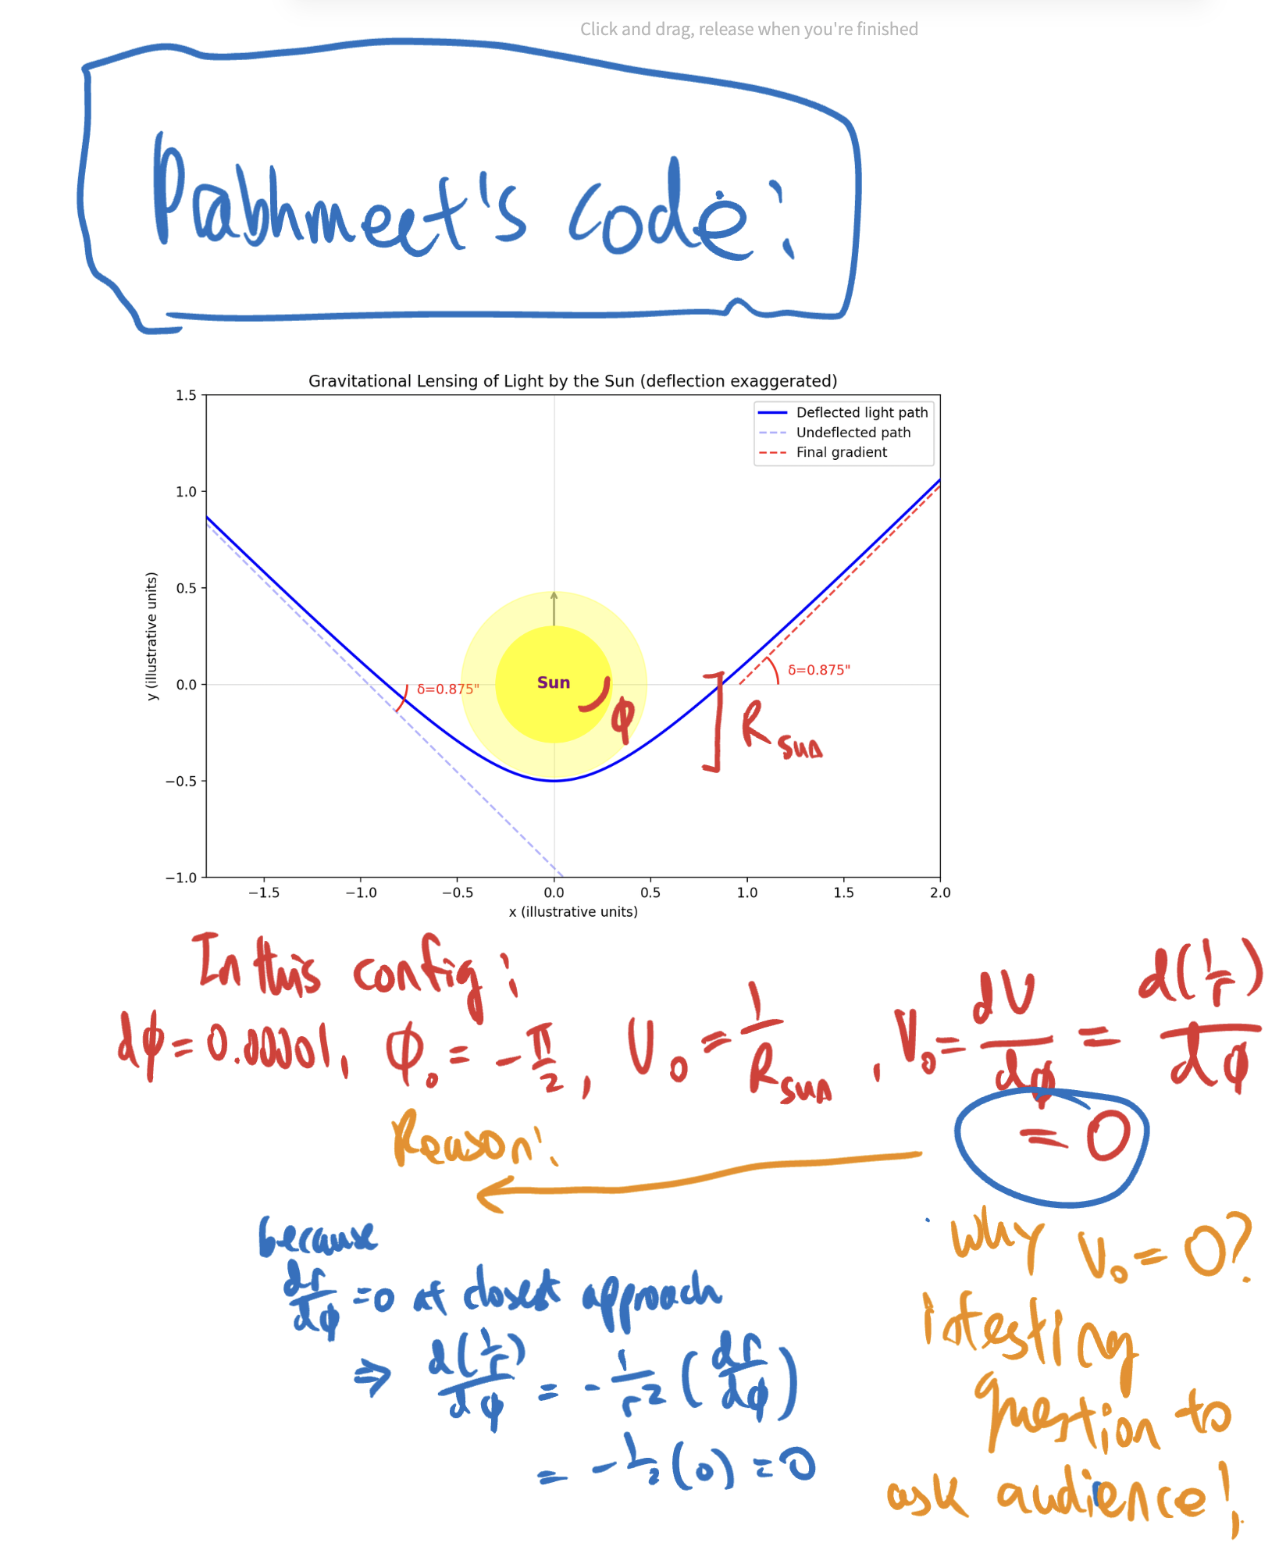
- This was a huge step forwards as we finally had some code working, but in order to raytrace the code needed to be modified so that we could initialise a light ray FROM THE EARTH
- 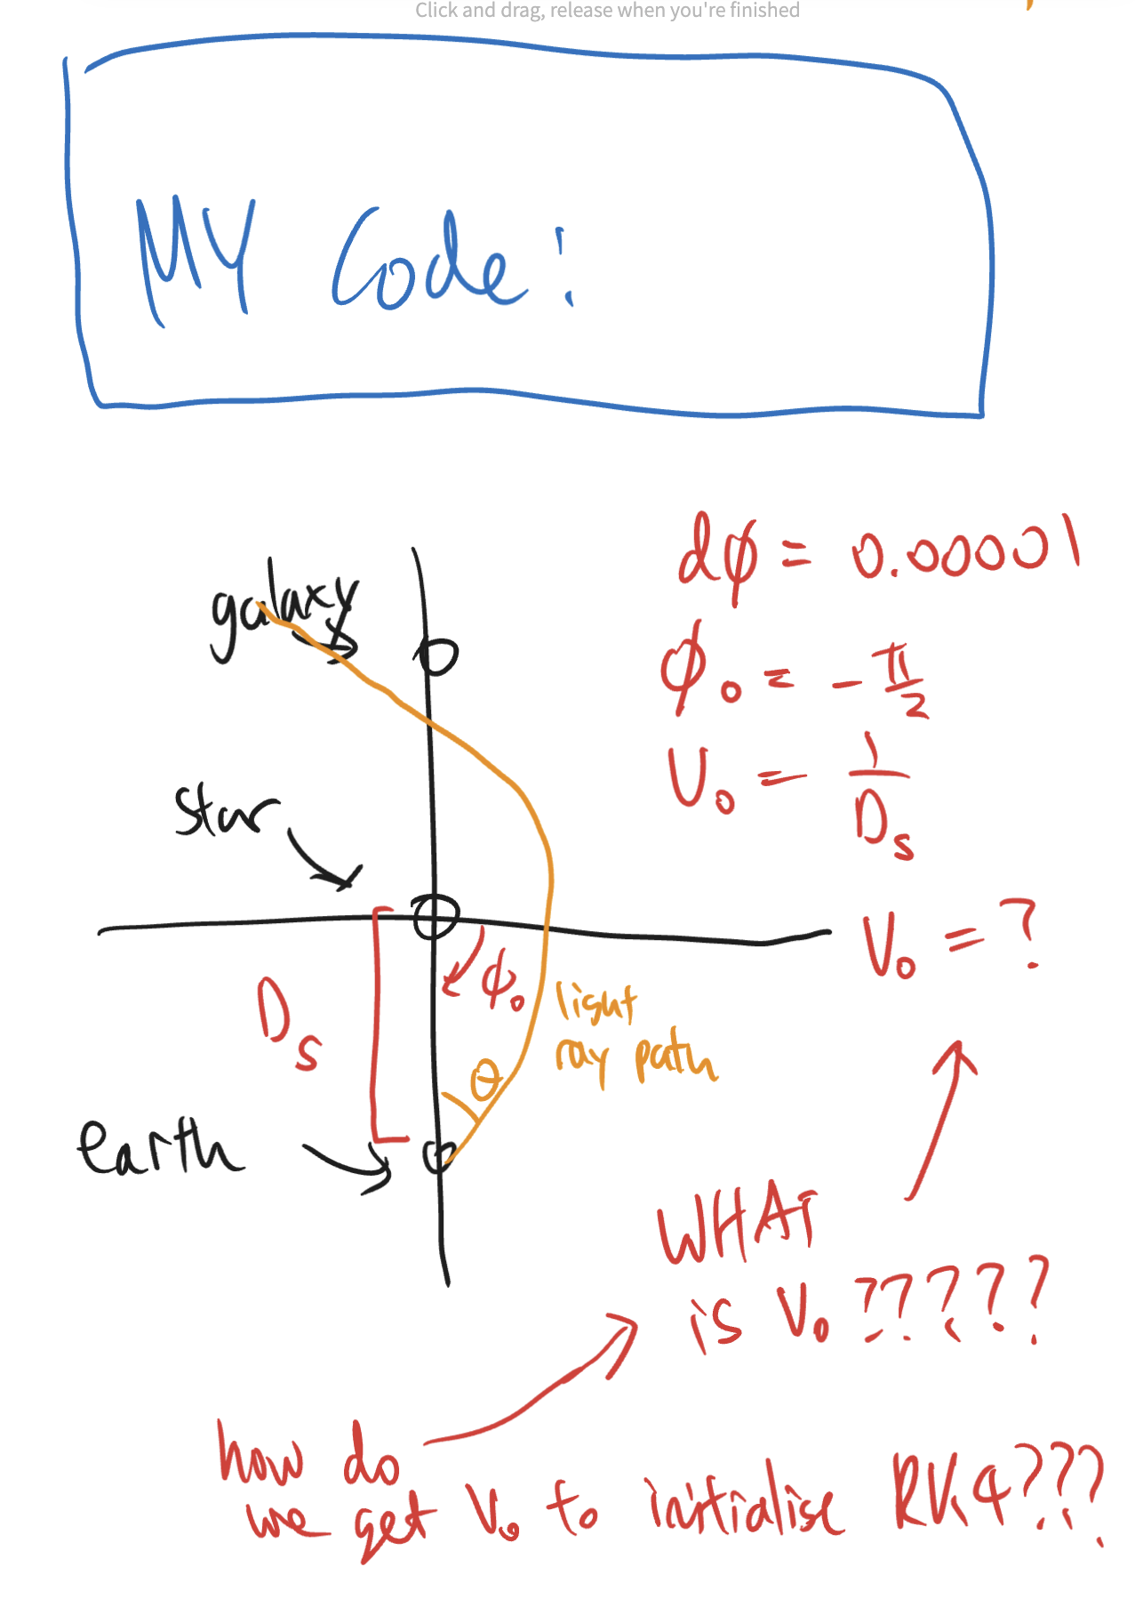
- How do we raytrace from the earth? We need V_0 to initialise RK4. How do we get V_0? Well simple math
- 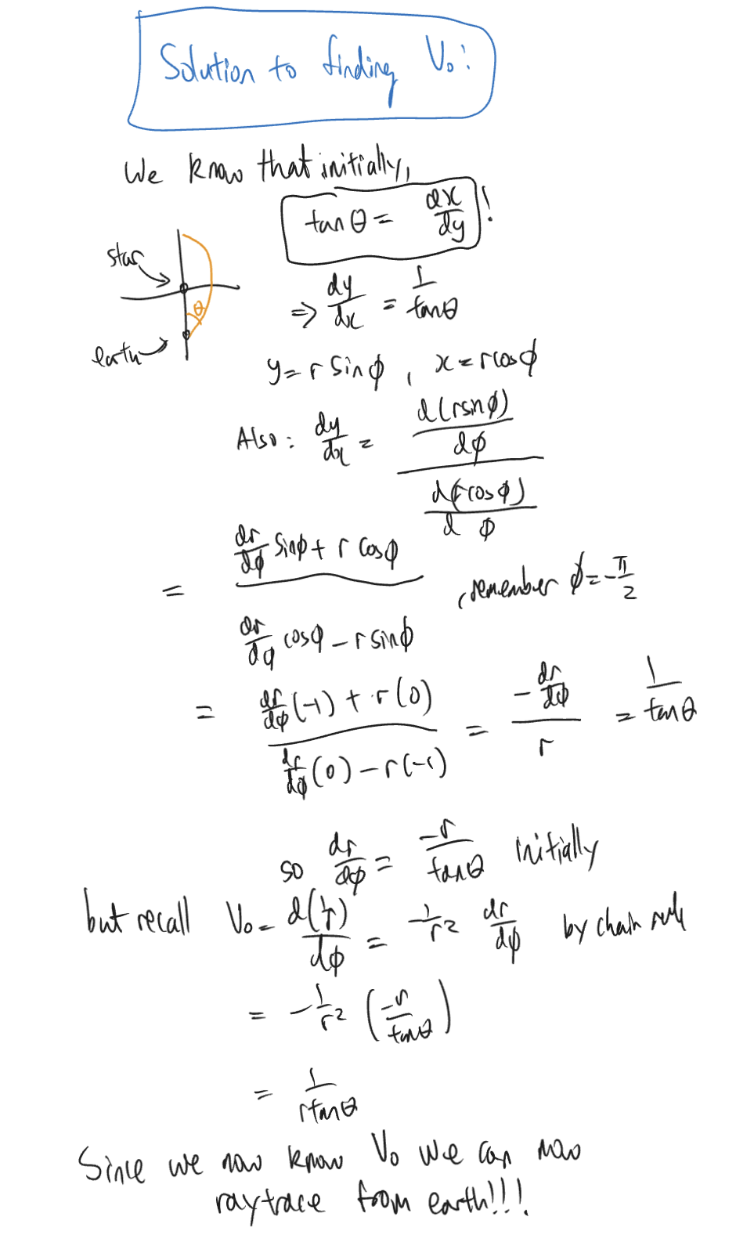
- Once we got this working I binary searched using our old method FULL IMAGES ON DISCORD
- 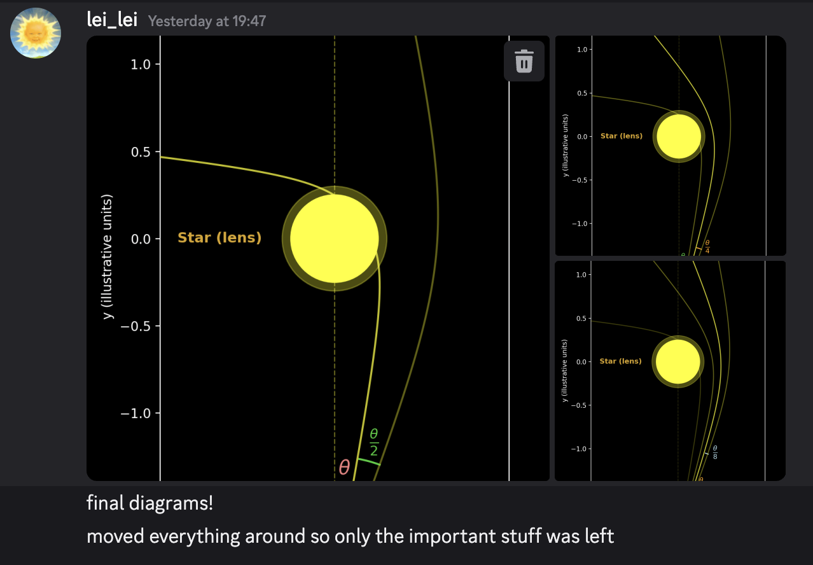
- ONLY PROBLEM NOW: OUR DATASUCKS (LOOK OUR LINE != THEIR LINE)
- 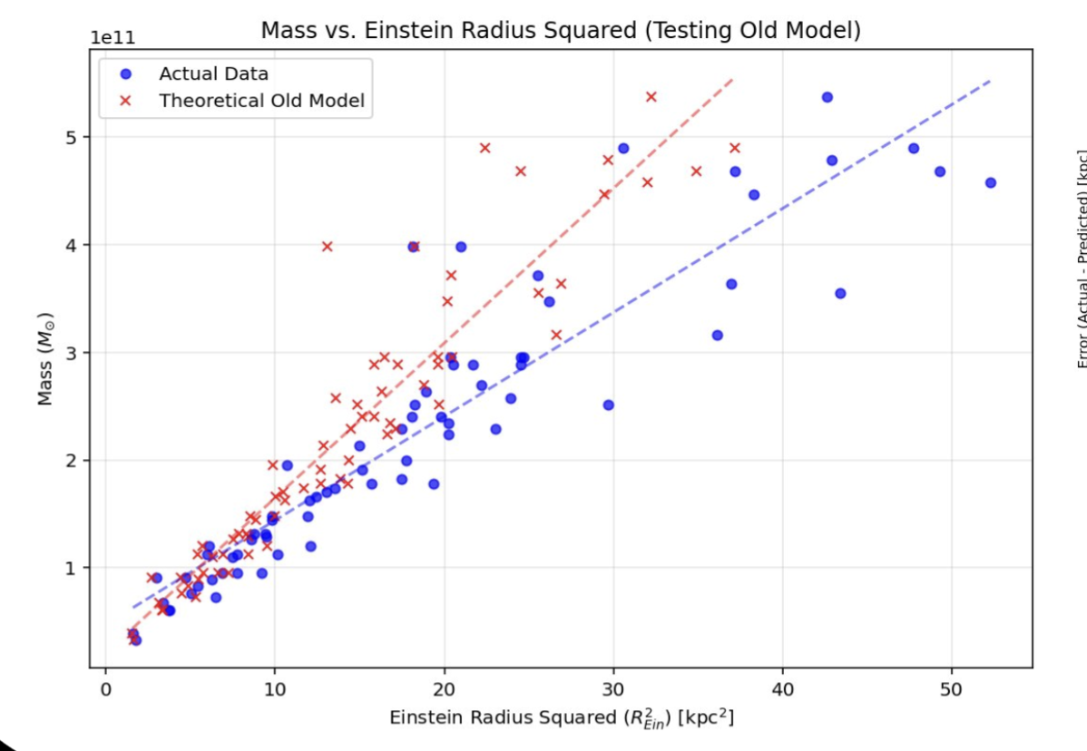
- REASON: EXPANSION OF THE UNIVERSE. D_L, D_S, D_LS VALUES DON’T ADD UP?!?!?!?!??!?!?!
- 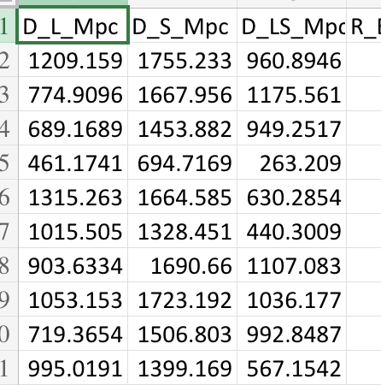
- Solution: cyrus formula
- 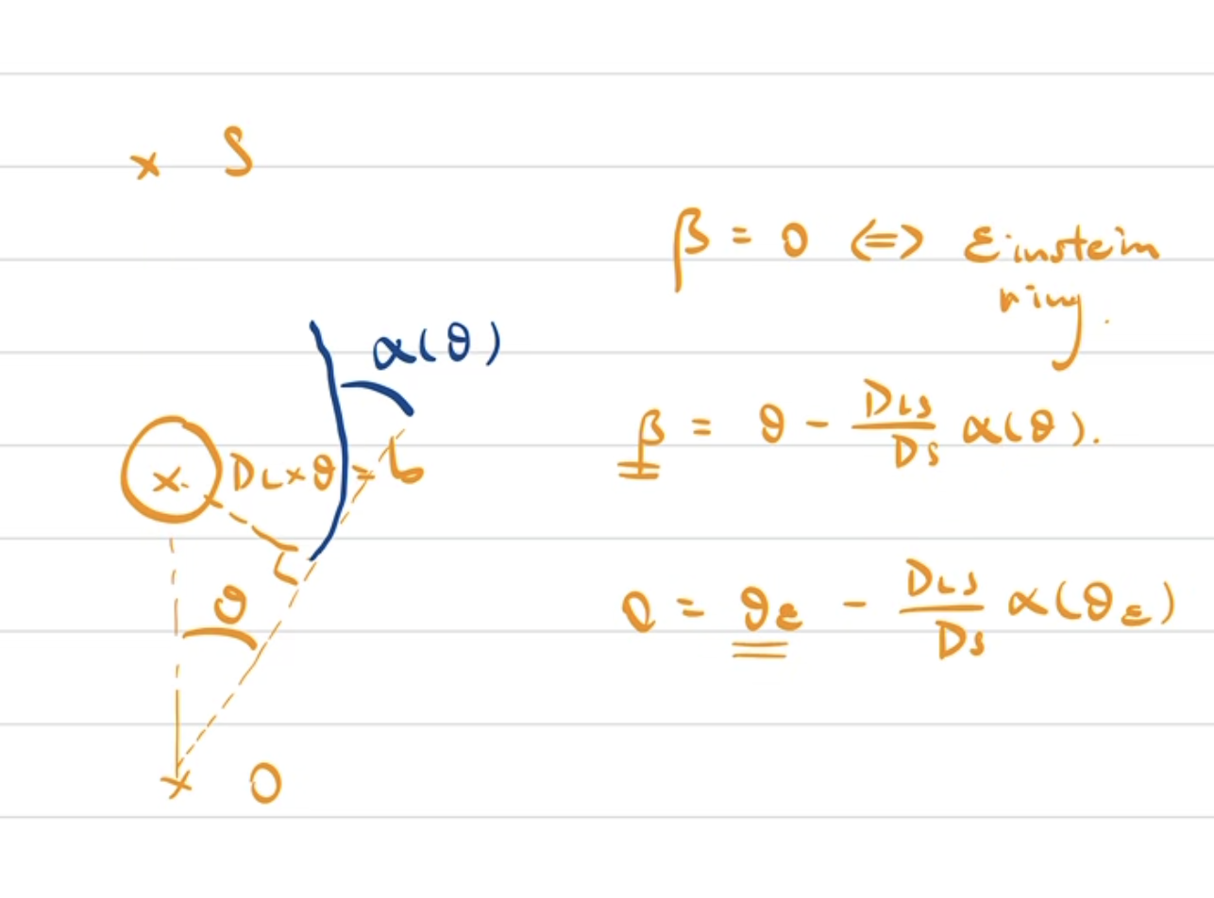
- WE CAN STILL BINARY SEARCH HERE! Notice as theta increase alpha (deflection) decreases so Beta = theta – constant * alpha HAS ONLY 1 ROOT (and continuous)
- AND WE CAN ONLY BINARY SEARCH FOR THIS ROOT! (SECOND GRAPH IS A GRAPH OF beta against theta like in the first graph that shows the function collapsing on beta = 0)
- 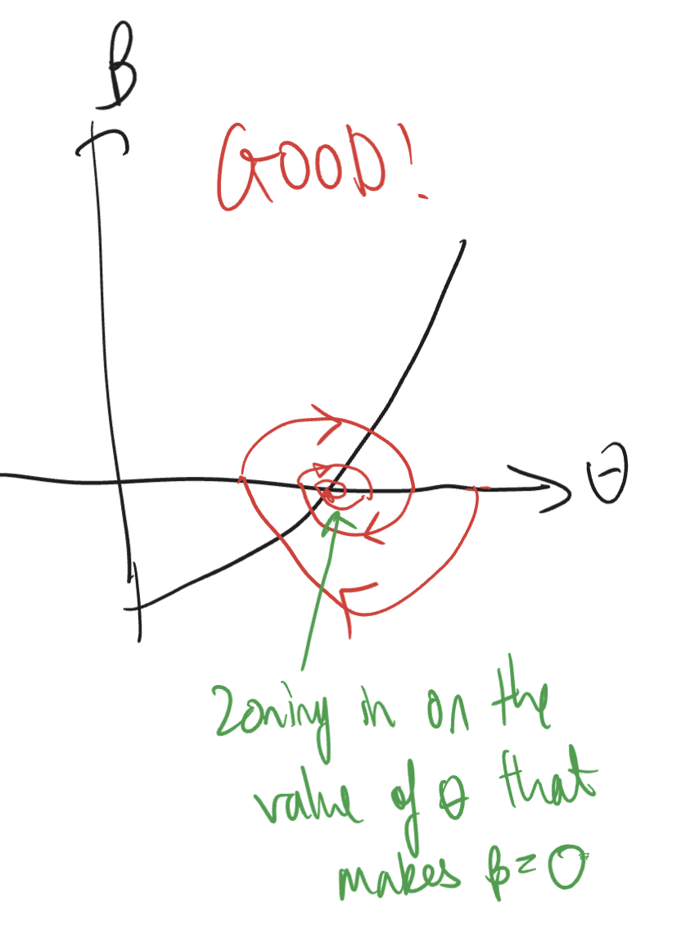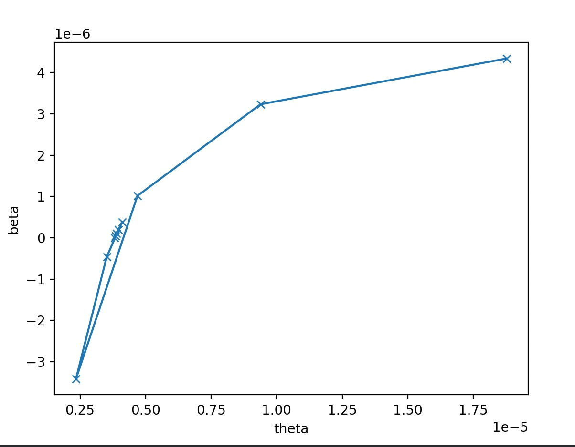
- Now graph good and we happy

Self-note of uncertainties:
- Computational underflow/overflow/rounding
- Approximation of lens as a point mass
- Approximation of background galaxy as a sphere
Ref 1THE SLOAN LENS ACS SURVEY. IX. COLORS, LENSING AND STELLA

The third prong
Our final prong involved comparing the geodesic model we created, with the data we compiled from the paper. We had to adjust our model slightly, by increasing the scale of our lenses, to more successfully match the scale of the data we collated from the paper. Also, there was a termination limit for the distances, which was adjusted to accommodate for the new large masses. Once that was done, we could compare the rk4 model to our data. Using python, we created a linear graph which used data points from various masses and their corresponding einstein ring radii, and plotted them. There was a clear relationship between the radius squared and the mass of the lens. We could then use this plot to compare to the data, and see if those data points from the data correlate to our plot.

Once we compared the plot with the data points, we could find error/variance data, to see quantitatively if the data was matching or mismatching. We found RMSE (root mean squared error), variance, and mean absolute error. We plotted an error graph which compared the observed and expected values for radius, the residuals, and we could see how large the errors were for each individual data point.
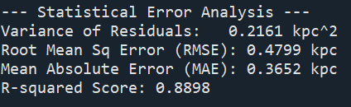
The R-squared score compares the squares of the residuals and the squares themselves, and this means that the RK4 model successfully explains 89% of the variance in the real-world dataset. The other 11% is due to universe messiness, such as dark matter.

Leiyi’s model of the binary stuff, there’s a systematic error, as you go to larger masses, the model becomes less accurate. WRITE ABOUT THIS ERROR

For any quantitative result purposes, we can code for 2D when it comes to the gravitational lensing. If we want an image, we needed to code for 3D.

Second was dark matter. Joseph and Cyrus were researching dark matter and how to measure it.

Dark matter contributes to five sixths of the universe’s matter, and the best way seems to be through gravitational lensing. The problem is that dark matter is not detectable with most detectors. It doesn’t emit, reflect, or absorb light of any wavelength. The way we know it exists is due to various evidence. For example, stars orbiting around Andromeda move too fast for the luminous (baryonic) material that exists in the galaxy. The luminous material in Andromeda is concentrated in the centre. Rotations at larger radii orbits ought to have slower angular velocities, but they orbit at the same rate as those near the centre, so there must be some more ‘hidden’ mass, “dark matter”, which accounts for this unusual orbiting behaviour.
How can we measure this dark matter? By modelling large galaxies as gravitational lenses, we could see how light is bent by the large galaxies, and using the appropriate equation, we can find the mass of said galaxy, and then compare that mass to the stellar mass of the galaxy. If the stellar mass was larger than the luminous mass, this difference was likely down to dark matter – this was our theory. We used our model of the star to determine the luminous mass, and then by comparing with real world data, we found that stellar mass was larger.
The third prong involved using our model of the star, and increasing its mass infinitely such that it modelled the effects of a black hole. We used python to model this black hole, and came up with an image of a black hole, using the model to determine the way each light ray bent. In order to model this, we used ray tracing. Using the same model we used to discover the Einstein ring, we can just maximise the mass, and we create a black hole gravitational lens. We can also find the angle of deflection of the black hole, and find the Close Impact parameter, which is the point of closeness that a light ray would fall into the black hole instead of deflecting. Again, this data with our model can be compared to existing data sets, to determine if our model is suitable. MAX OUT MASS

